Control_Structures:

-- Scenario 1

BEGIN

    FOR cust_rec IN (SELECT CustomerID, DOB FROM Customers) LOOP

        IF MONTHS_BETWEEN(SYSDATE, cust_rec.DOB) / 12 > 60 THEN

            UPDATE Loans

            SET InterestRate = InterestRate - 1

            WHERE CustomerID = cust_rec.CustomerID;

        END IF;

    END LOOP;

    COMMIT;

END;

SELECT NAME, DOB, BALANCE, LASTMODIFIED FROM CUSTOMERS;

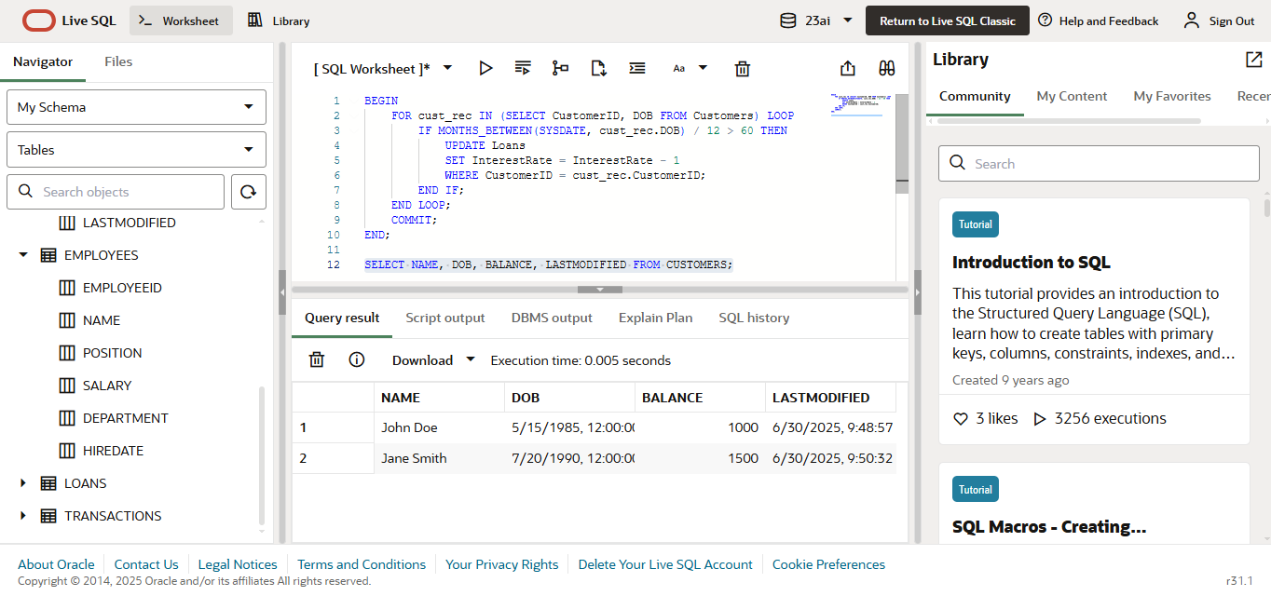

--Scenario 2

ALTER TABLE Customers ADD IsVIP VARCHAR2(5);

BEGIN

    FOR cust_rec IN (SELECT CustomerID, Balance FROM Customers) LOOP

        IF cust_rec.Balance > 10000 THEN

            UPDATE Customers

            SET IsVIP = 'TRUE'

            WHERE CustomerID = cust_rec.CustomerID;

        ELSE

            UPDATE Customers

            SET IsVIP = 'FALSE'

            WHERE CustomerID = cust_rec.CustomerID;

        END IF;

    END LOOP;

    COMMIT;

END;

SELECT * FROM CUSTOMERS;

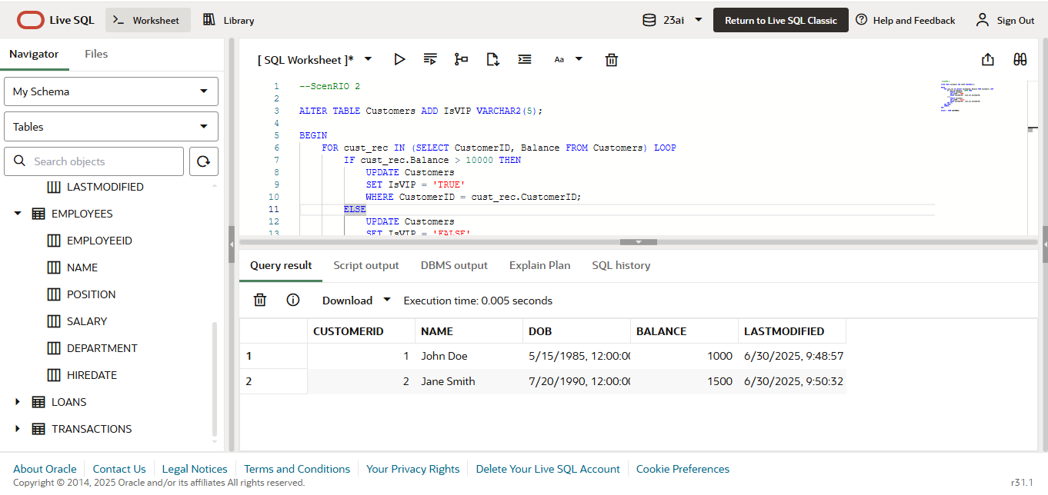

--scenario 3

BEGIN

FOR loan_rec IN (

SELECT L.LoanID, C.Name, L.EndDate

FROM Loans L

JOIN Customers C ON L.CustomerID = C.CustomerID

WHERE L.EndDate BETWEEN SYSDATE AND SYSDATE + 30

) LOOP

DBMS_OUTPUT.PUT_LINE(

'Reminder: Dear ' || loan_rec.Name ||

', your loan (Loan ID: ' || loan_rec.LoanID ||

') is due on ' || TO_CHAR(loan_rec.EndDate, 'DD-MON-YYYY') ||

'. Please ensure timely payment.'

);

END LOOP;

END;

SELECT * FROM LOANS;

